R. Reports Menu: Q. Tax Summary Report

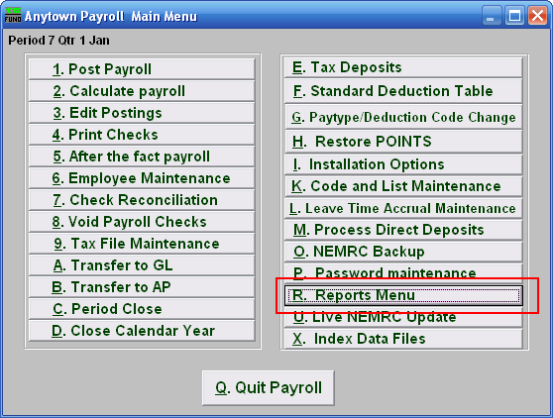
Click on “R. Reports Menu” from the Main Menu and the following window will appear:

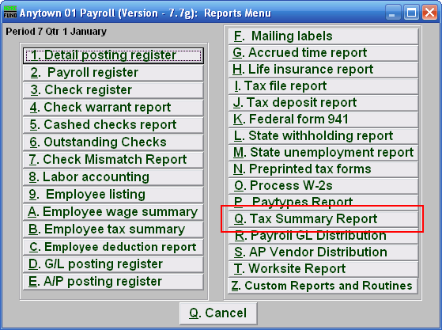

Click on “Q. Tax Summary Report” from the Reports Menu and the following window will appear:

Tax Summary Report

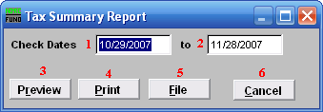
- Check Dates: Enter the beginning check issue date for the report to start on.

- to: Enter the ending check issue date for the report to end on.

- Preview: Click this button to preview this report. Refer to GENERAL PREVIEW for more information.

- Print: Click this button to print this report. Refer to GENERAL PRINTING for more information.

- File: Click this button to save this report on this computer. Refer to GENERAL FILE for more information.

- Cancel: Click “Cancel” to cancel and return to the Reports Menu.

